Department of Computing

School of Electrical Engineering and Computer Science

CS-250: Data Structure and Algorithms
Class: BSAI 2A

Lab 4: Doubly & Circular Linked List

Date: 30th September 2026
Time: 10:00 am – 12:50 pm

NAME | Muhammad Kundi
CMS ID | 577173

GITHUB LINK : https://github.com/mkundibsai25seecs/DSA-Lab1

Doubly Linked List
Introduction:
This lab is focused on implementing and exploring two important types of linked lists: Doubly Linked Lists (DLL) and Circular Linked Lists (CLL). In this session, students will learn how these data structures are created, how nodes are connected using pointers, and how traversal can be performed in both directions (for DLL) or in a circular fashion (for CLL).
Objectives:
The objectives of this lab are:
- To understand the concepts of Doubly Linked List (DLL) and Circular Linked List (CLL).
- To learn how to create, traverse, insert, and delete nodes in DLL and CLL.
- To compare the advantages and limitations of DLL and CLL with singly linked lists.
- To develop problem-solving skills by implementing real-world scenarios using DLL and CLL.
Tools/Software Requirement:
Visual Studio Code in Unix/Linux Environment.
Doubly Linked List:
A Doubly Linked List (DLL) contains an extra pointer, typically called previous pointer, together with next pointer and data which are there in singly linked lis
Task 1:
Write a program to implement a playlist management system using a doubly linked list. Each node of the list should store the following information about a song:
- Song ID (integer)
- Song Name (string)
- Duration (minutes:seconds)
Your program should support the following operations:
- Add Song – Insert a new song at the end of the playlist.
- Delete Song – Remove a song by its ID.
- Display Playlist Forward – Show all songs from first to last.
- Display Playlist Backward – Show all songs from last to first.
- Search Song – Search for a song by its ID and display its details.
- Play Next / Previous Song – Move forward or backward in the playlist (simulating a music player).
- Reverse Playlist – Reverse the entire playlist in place using pointer manipulation.
Circular Linked List
Circular Linked List:
Circular linked list is a linked list where all nodes are connected to form a circle. There is no NULL at the end. A circular linked list can be a singly circular linked list or doubly circular linked list.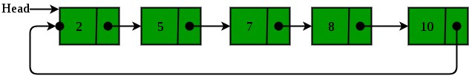

Josephus Problem Simulation
Task 1 — Part A: Doubly Linked List

CODE :
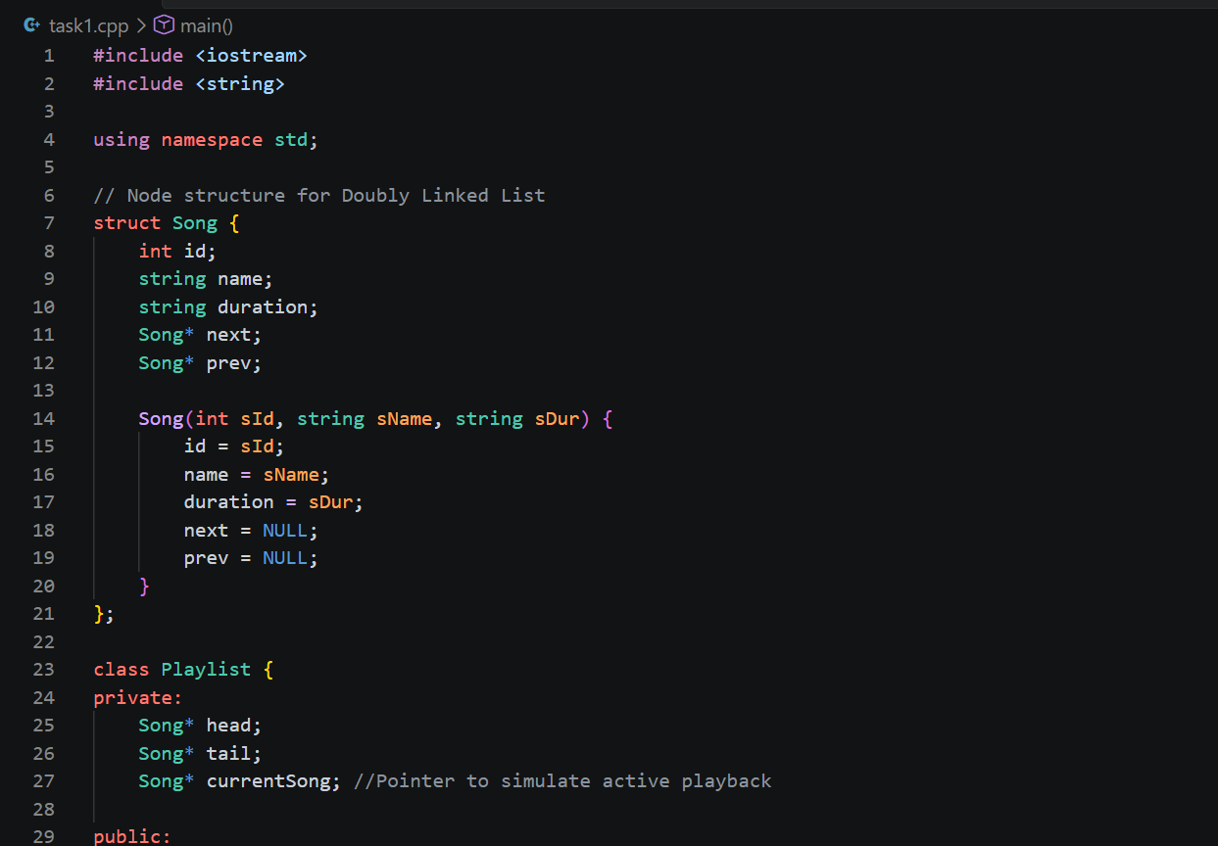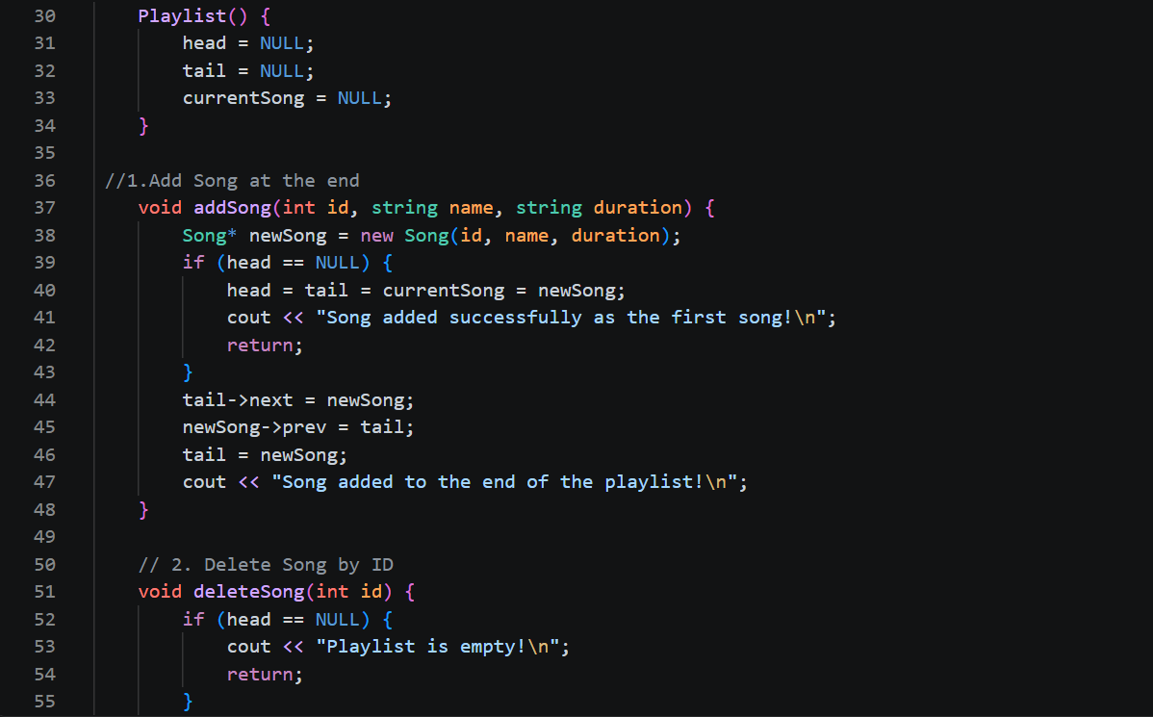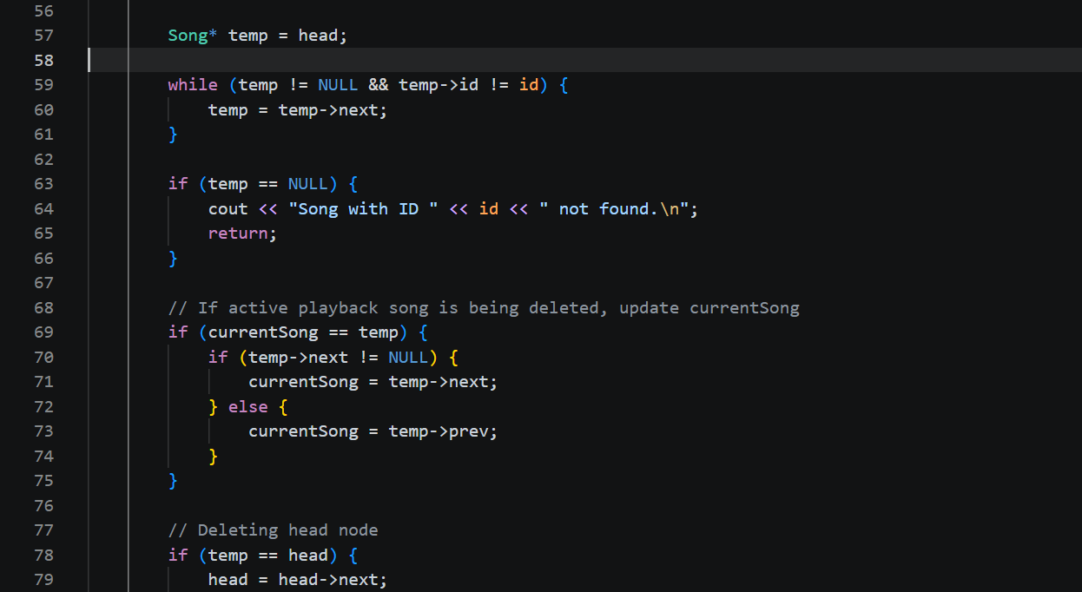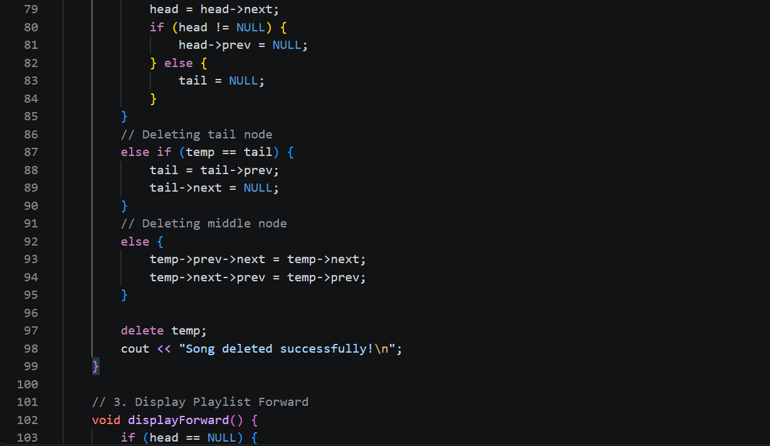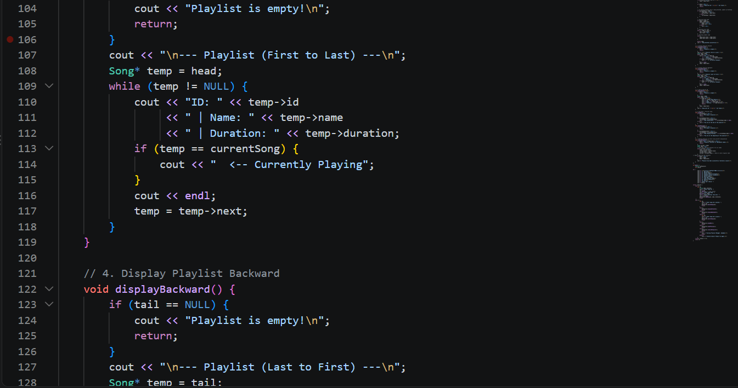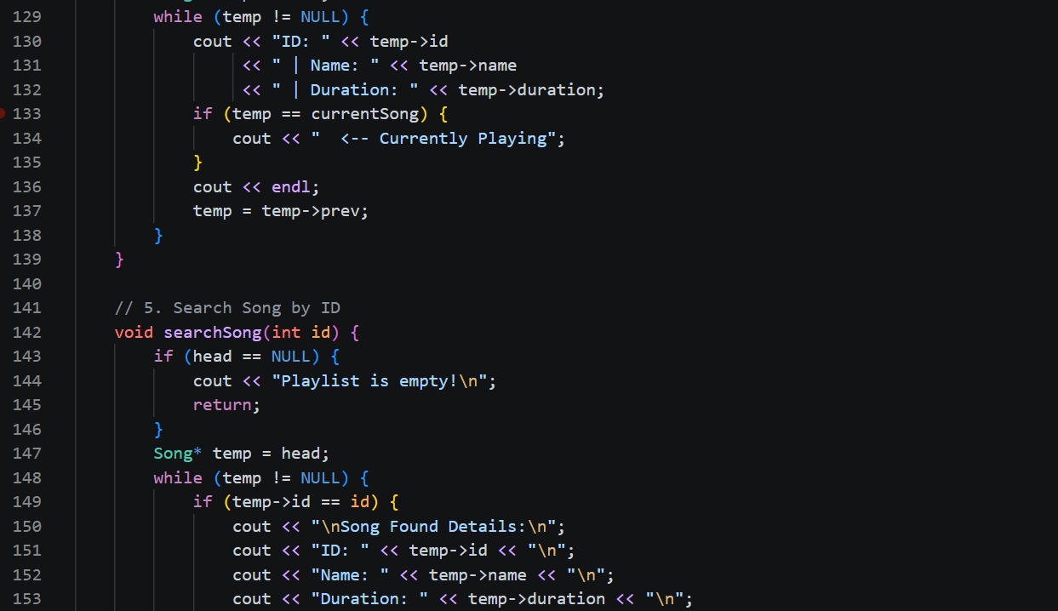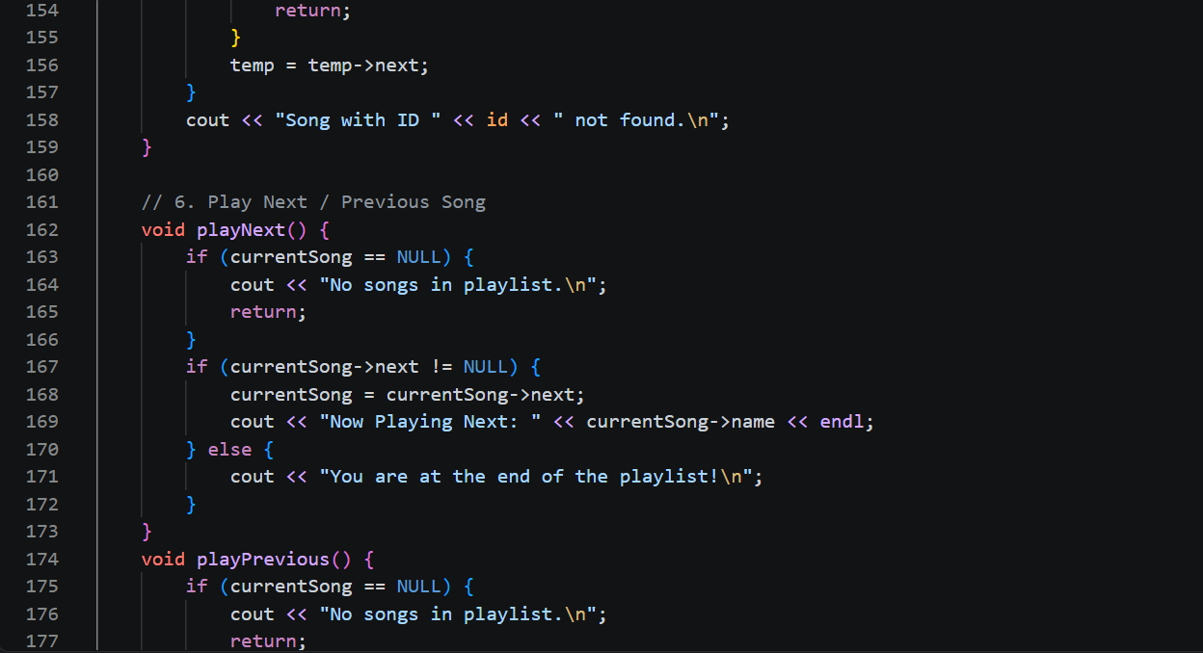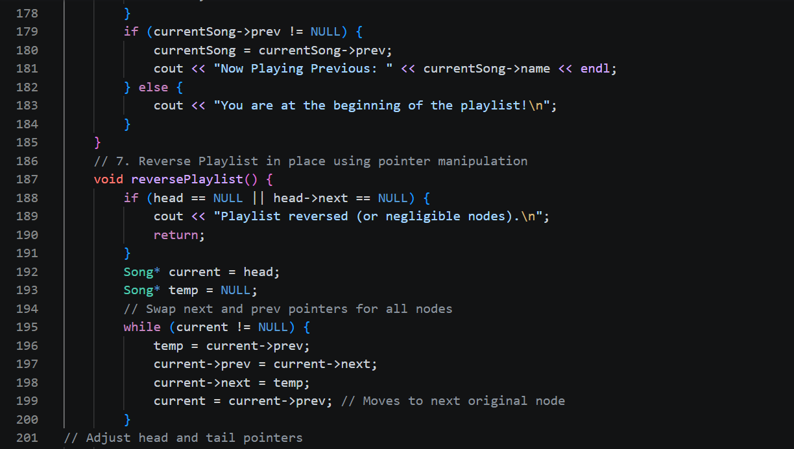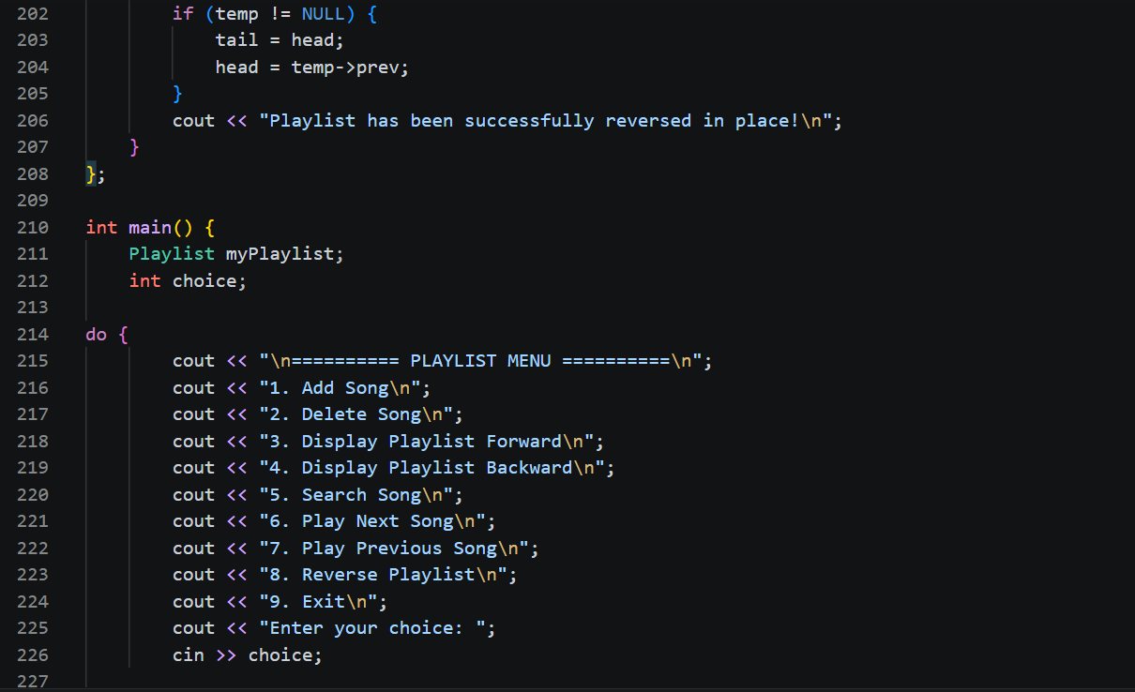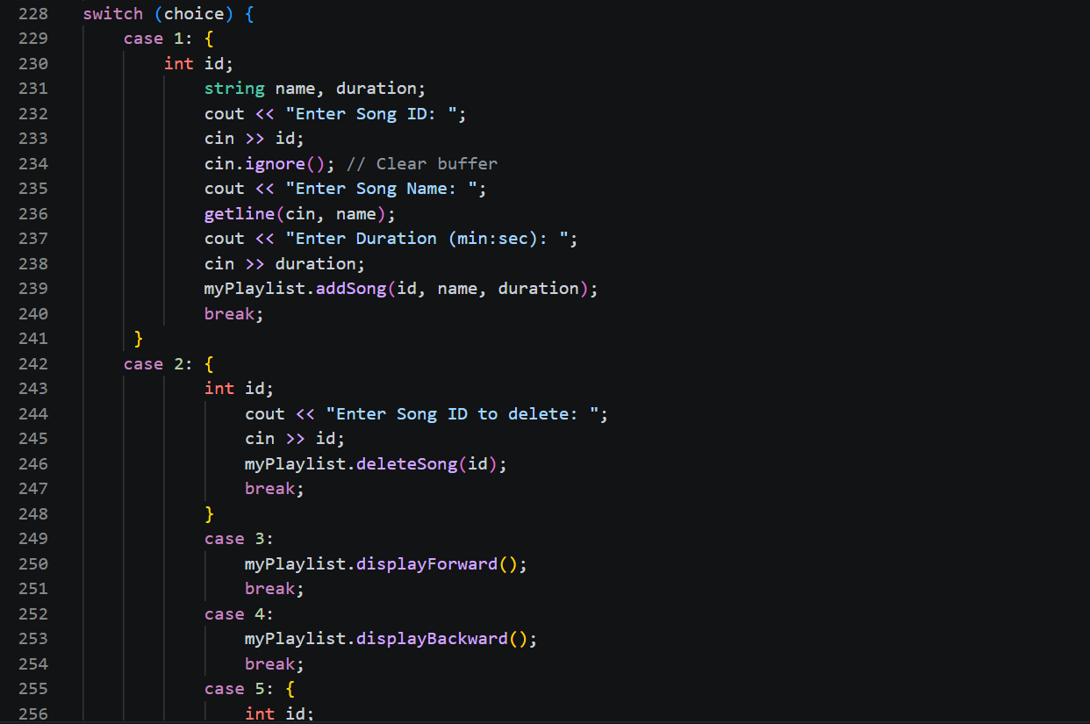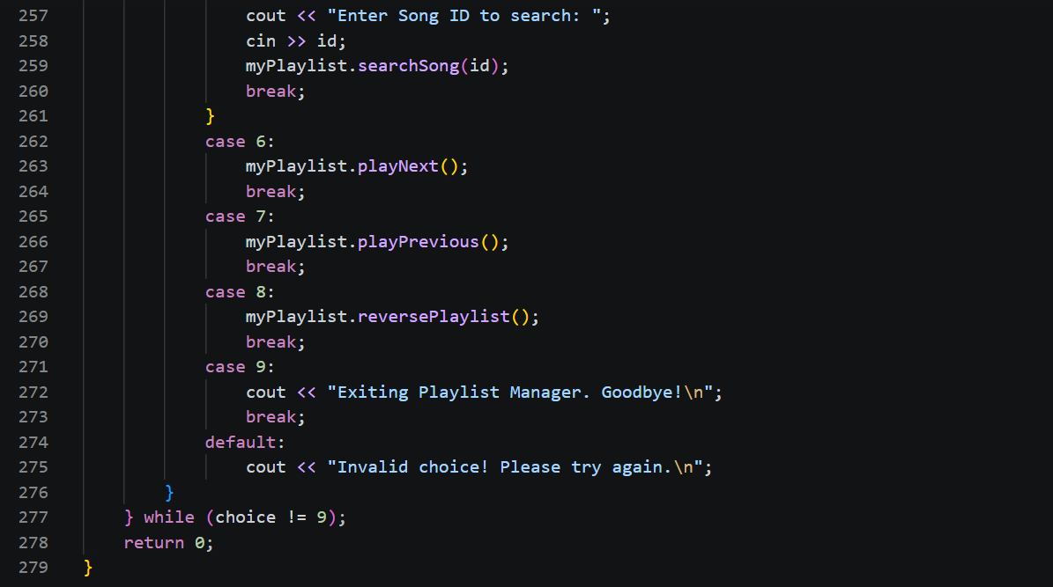

OUTPUT :
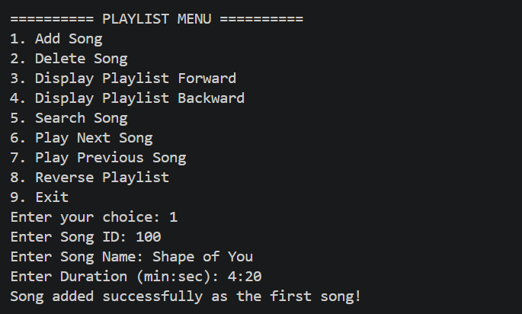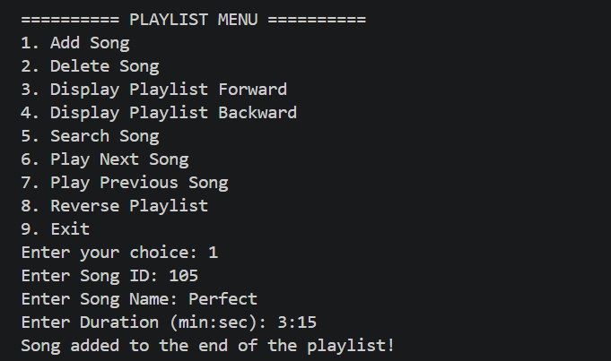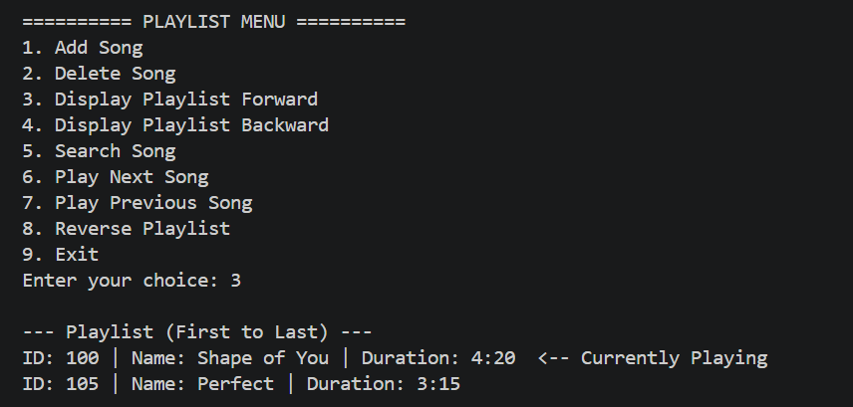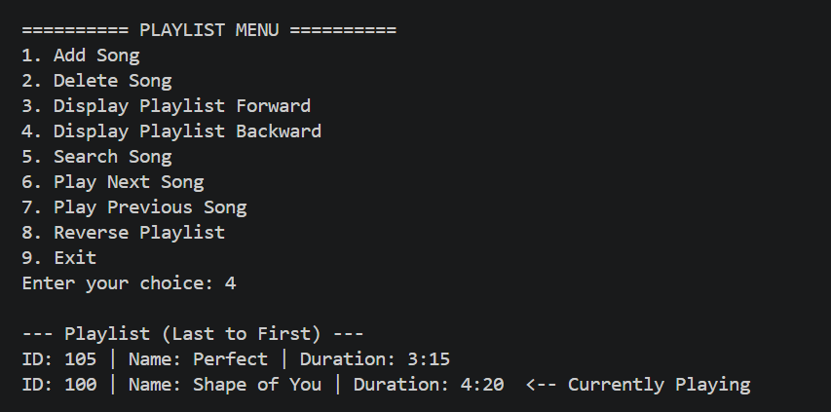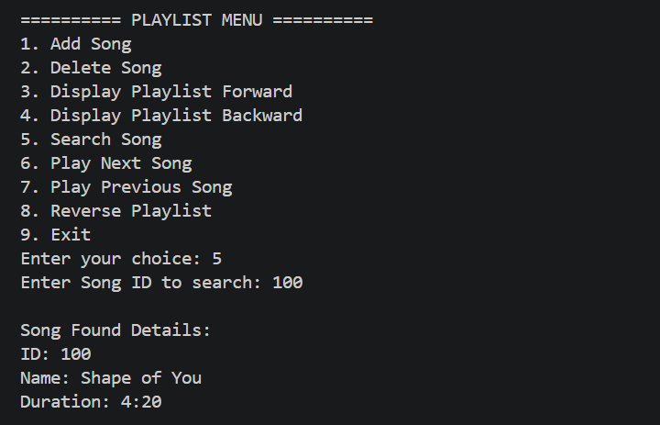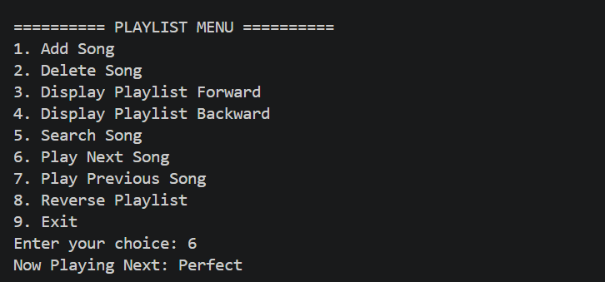

Background:
The Josephus Problem is a famous theoretical problem in computer science and mathematics. A group of people stands in a circle, and counting begins from a specified starting point. Every k-th person is eliminated from the circle, and the counting resumes from the next person. This continues until only one person remains, who is considered the "survivor."This problem can be effectively modeled using a circular linked list, since the last person is followed by the first, and eliminations require efficient pointer updates.
Task 2:
Write a program to simulate the Josephus Problem using a circular linked list.
- Input Requirements:
  - Number of people, N (each person assigned an ID: 1, 2, …, N).
  - Step count, k (the interval at which a person is eliminated).
- Circular Linked List Representation:
  - Each node should represent a person with:
    - Person ID (integer).
    - Pointer to the next person (circular linkage).
- Operations to Implement:
  - Create Circle – Build a circular linked list of N people.
  - Elimination Process – Starting from person 1, eliminate every k-th person. Update the links after each elimination.
  - Display Eliminated Order – Print the order in which people are eliminated.
  - Display Survivor – At the end, print the ID of the last surviving person.

TASK 2 _Circular Linked List / Josephus Problem:

CODE:
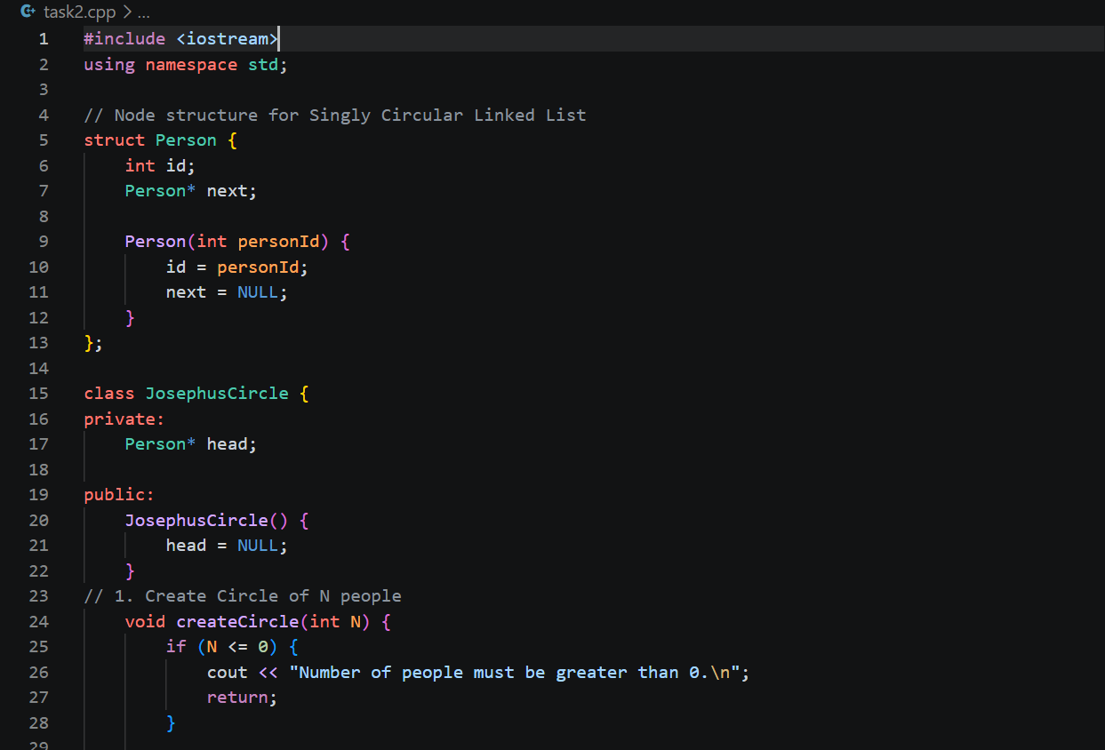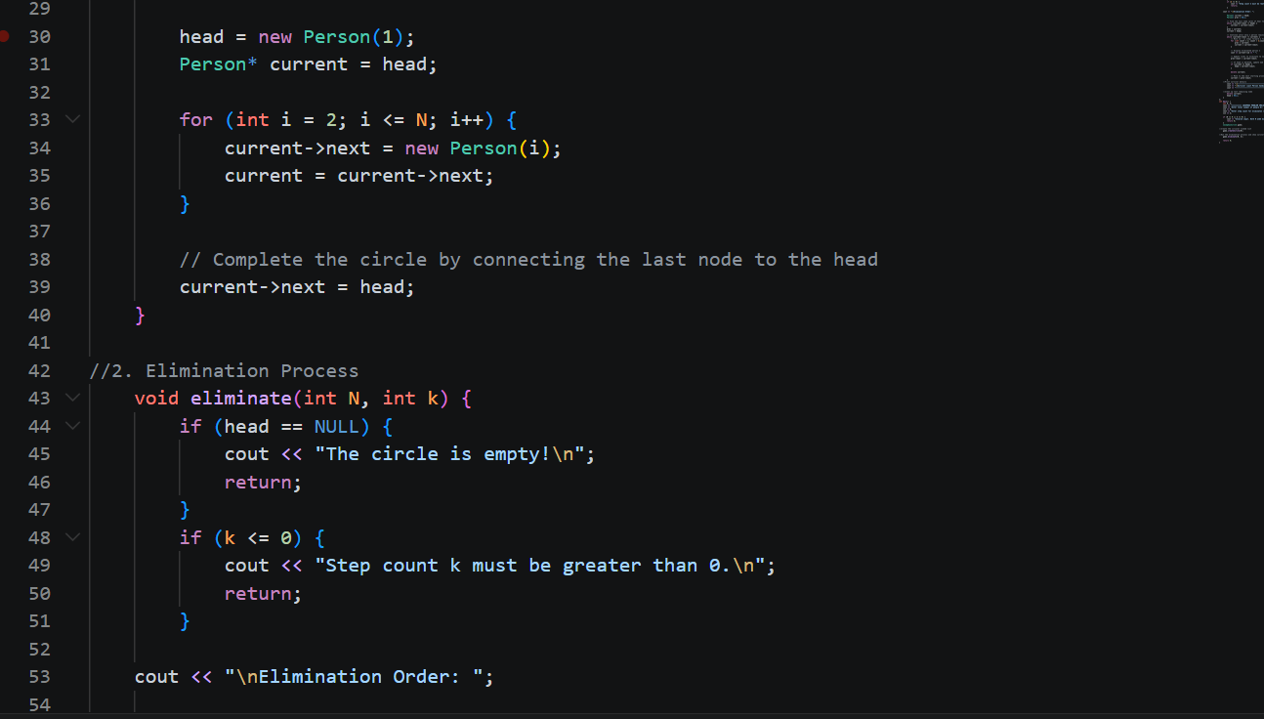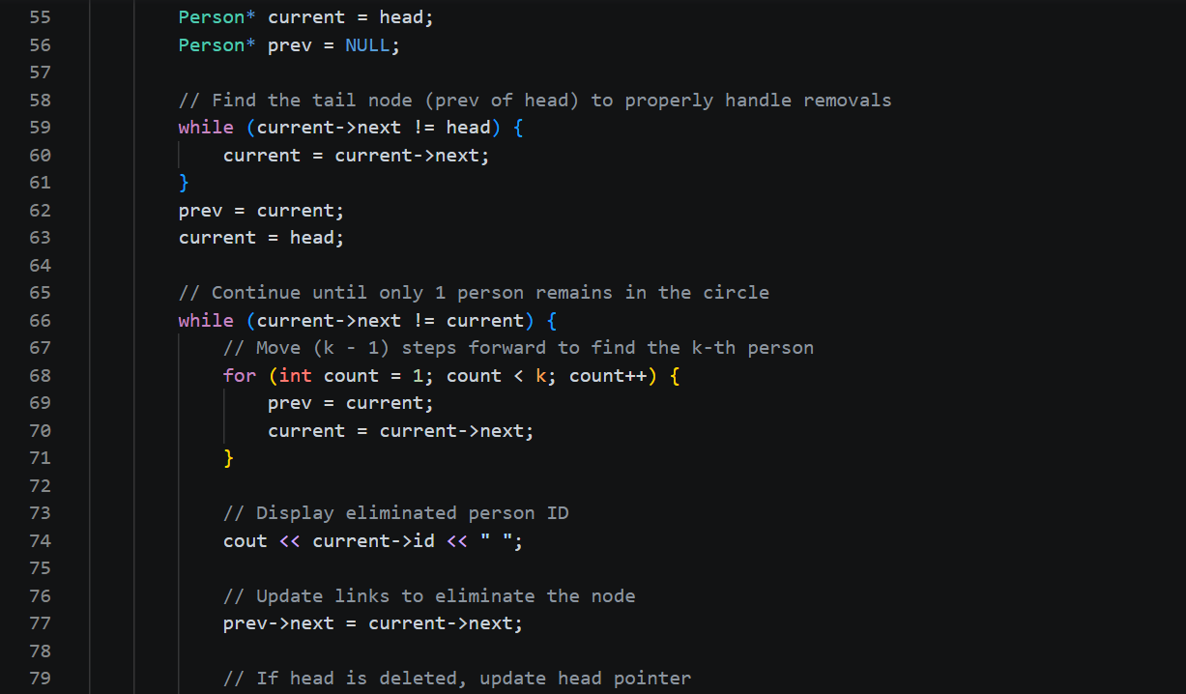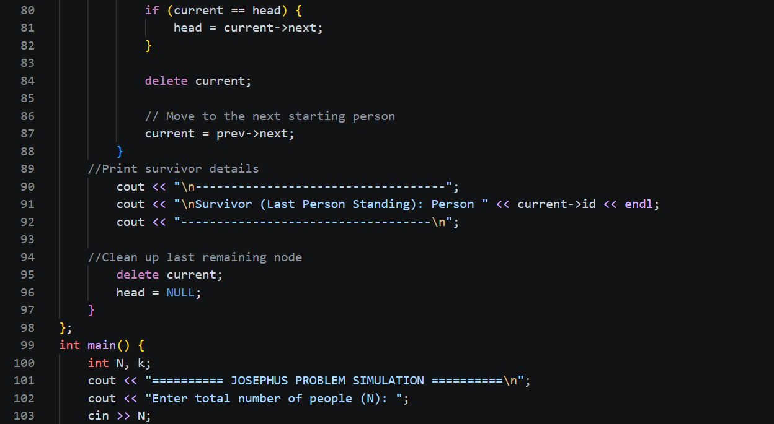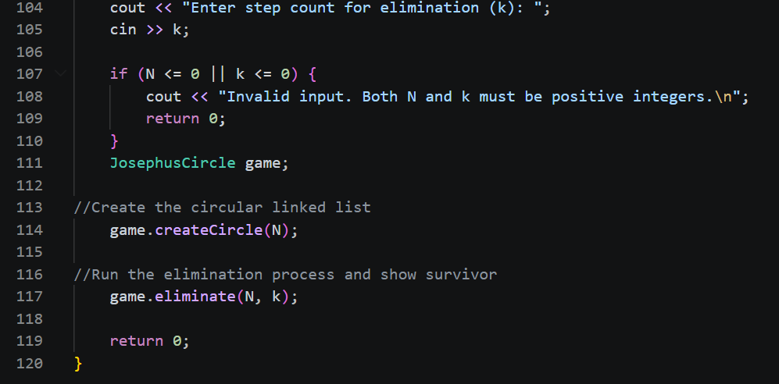
OUTPUT:
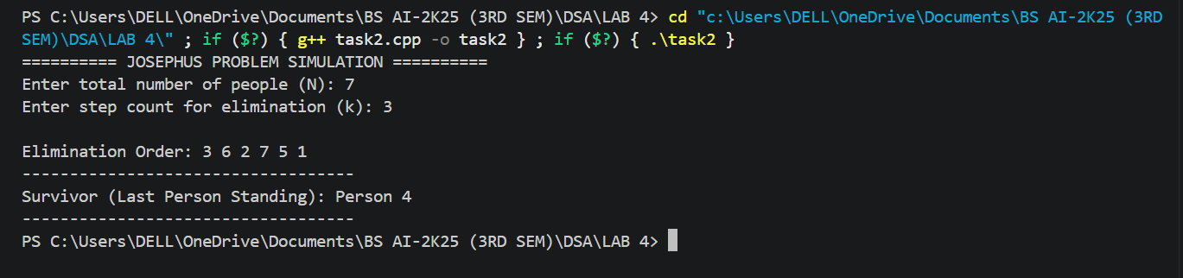
Task 3:
Write a program to simulate binary arithmetic operations using Doubly Linked List (DLL). Each bit of the binary number should be stored in a node of the DLL, where each node contains:
- bit (0/1)
- pointer to next
- pointer to previous
The program should support the following operations:
- Store Binary Number – Take input as a sequence of bits and store it in an 8-bit grouped doubly linked list format. Extend to multiple 8-bit blocks if the number exceeds 8 bits.
- 1’s Complement – Traverse the DLL and flip all bits.
- 2’s Complement – Compute 1’s complement, then add 1 (using binary addition via DLL).
- Binary Addition – Add two binary numbers stored in DLL, handling carries properly.
- Binary Multiplication – Implement binary multiplication using repeated addition + shifting stored in DLL.
- Conversion to Decimal – Convert a binary number stored in DLL to its decimal equivalent and display it.
CODE:
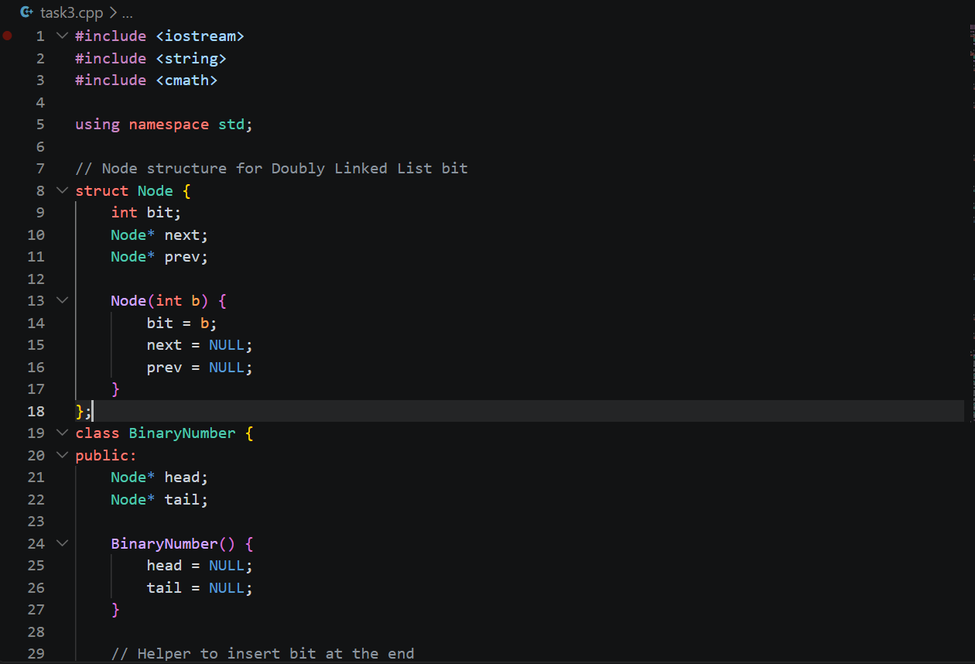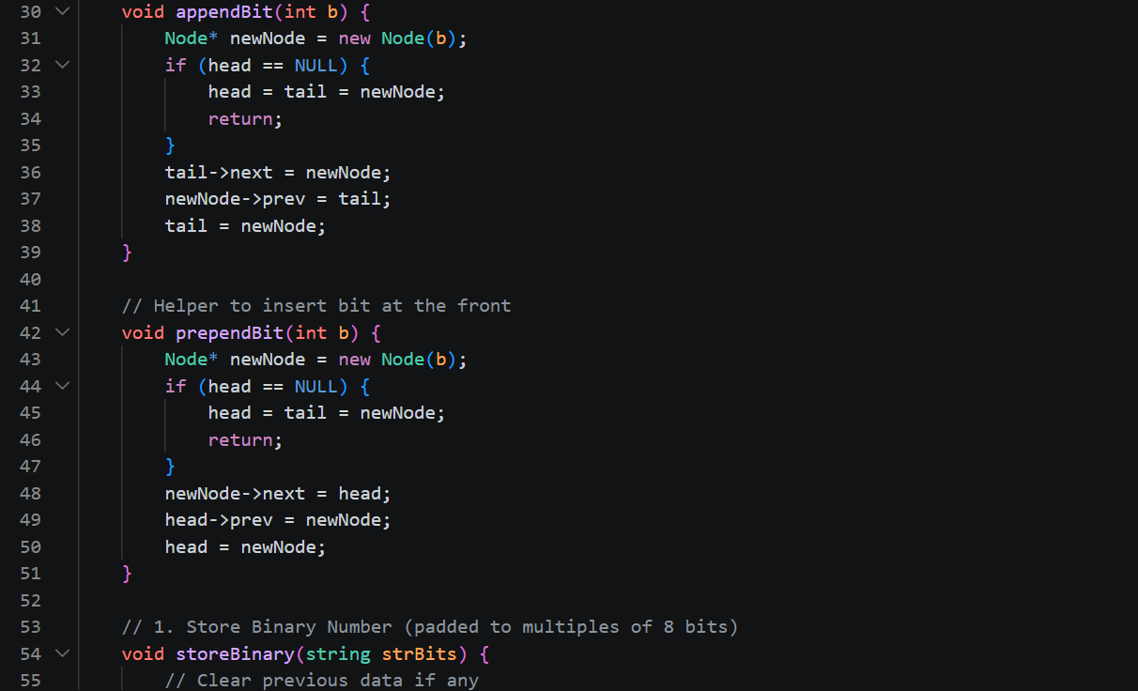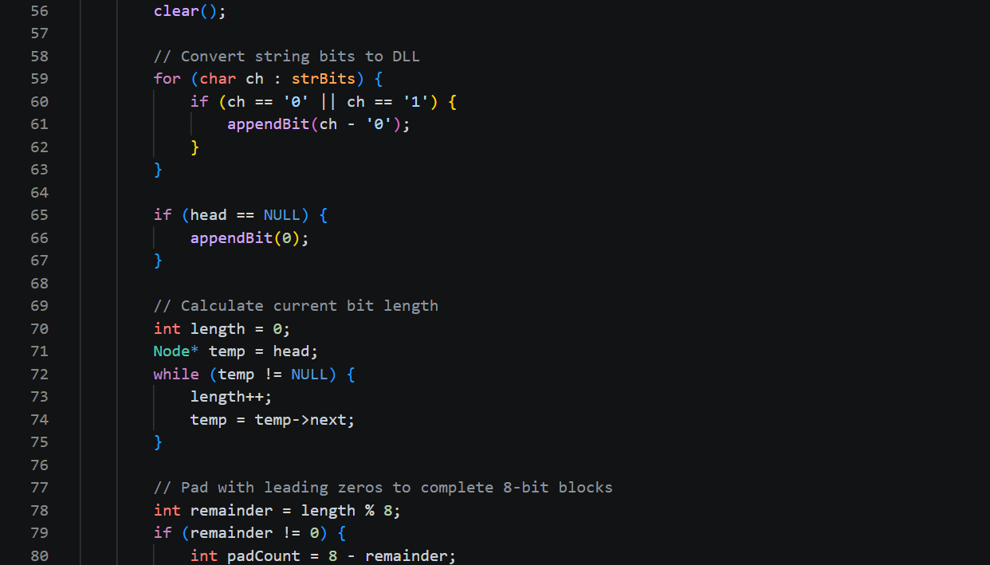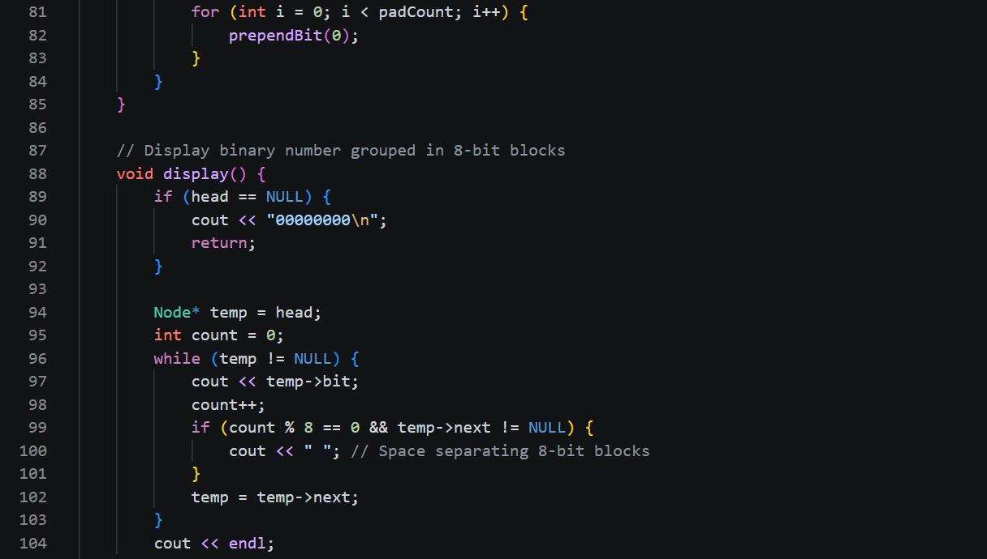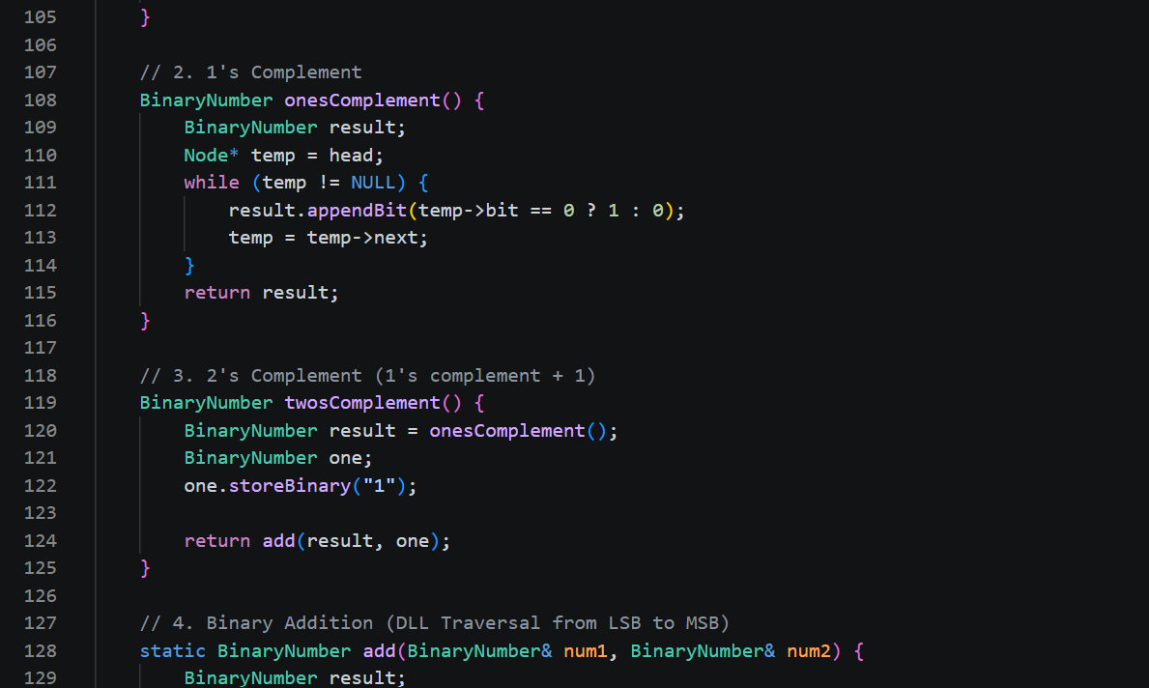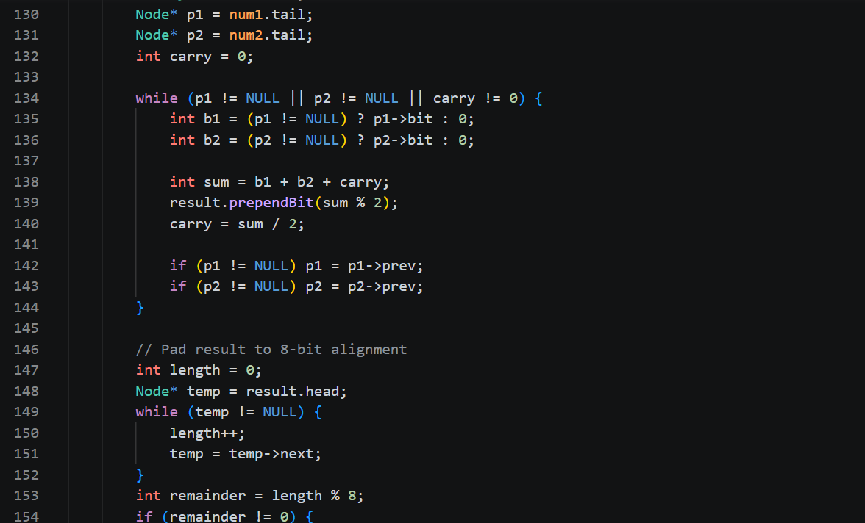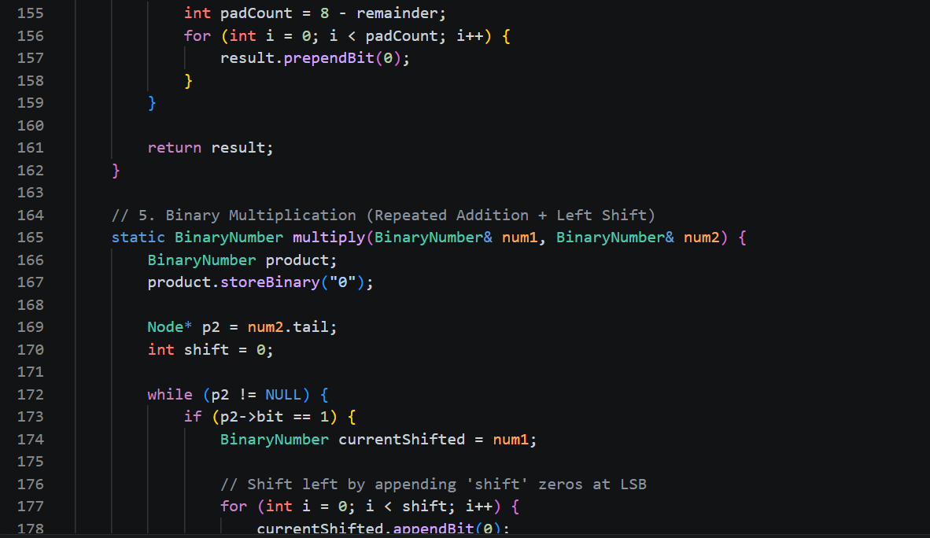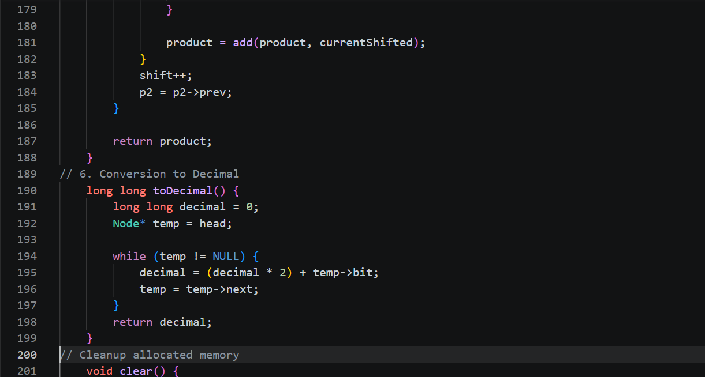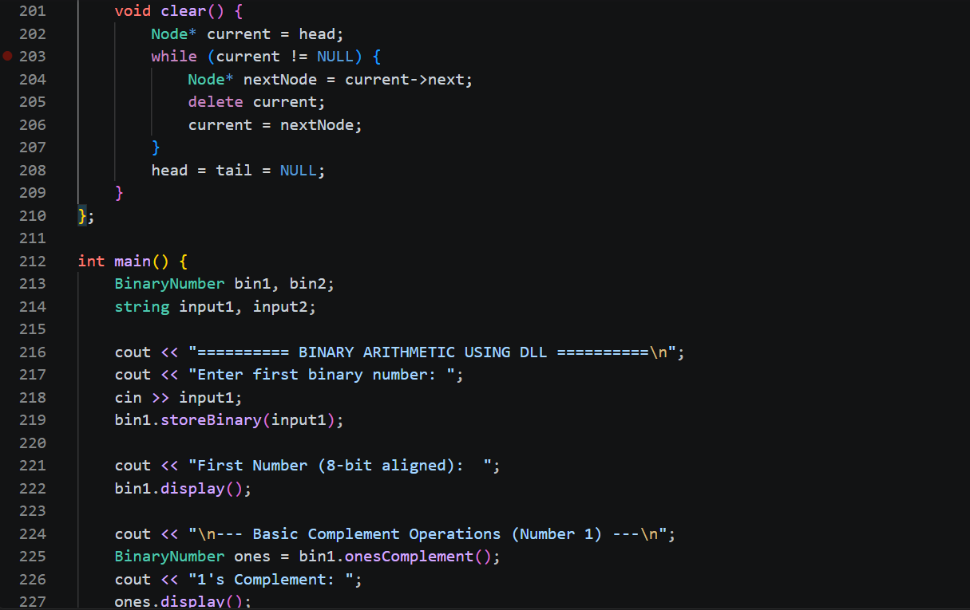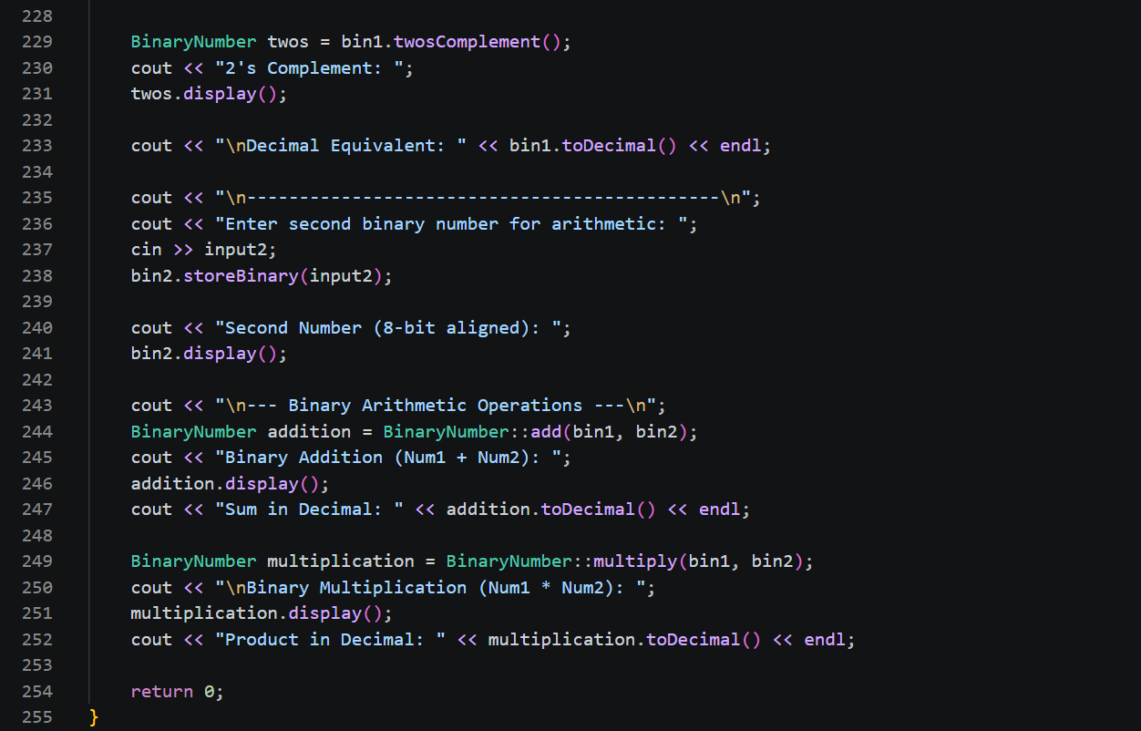
OUTPUT:
